.

Cover
Groupe Nduom
Marks
10 Years
Of Banking
Service
In Liberia
Story: Atta Kwaku Boadi
Marking a major milestone in Liberia’s financial sector, Dr. Papa Kwesi Nduom, Chairman of Groupe Nduom, delivered a heartfelt address reflecting on ten years of GN Bank Liberia Limited’s operations in the country.

Grounding his address in the biblical promise of Jeremiah 29:11, Dr. Nduom expressed deep gratitude to the nation, its regulators, and its leadership for a decade of sustained partnership.

Reflecting on the institution’s journey since its launch—when it first promised to serve the Liberian people with excellence—Dr. Nduom highlighted the formidable realities of navigating the continent’s commercial landscape.

“It takes tons of courage to start and operate a business in Africa,” Dr. Nduom said during the anniversary event. “It is even tougher to operate successfully in a regulated business such as banking, not just in Africa, but all the world over. So, it is important to pause, show gratitude to those who have supported and continue to support us to stay in business.”

A central theme of the astute entrepreneur’s address was the continuity of support GN Bank had received from successive Liberian governments.

Dr. Nduom extended appreciation to three consecutive administrations, acknowledging the encouragement provided by former Presidents Ellen Johnson Sirleaf, George Weah, and incumbent President Joseph Boakai.

He also commended the Central Bank of Liberia (CBL) for its critical regulatory guidance and for maintaining the institution's licence to operate.

Highlighting Groupe Nduom’s broader contribution to the national economy, the Groupe Nduom chairman pointed to the success of its affiliate, the Liberia Enterprise Development Finance Company (LEDFC).
Through joint cooperation between the CBL, the Liberian government, and international partners, LEDFC, he said had injected over $30 million in investment funds into indigenous Liberian enterprises.

Addressing stakeholders directly, Dr. Nduom reaffirmed the bank’s commitment to former clients of the First International Bank of Liberia, the CBL, and the general public.

He pledged that GN Bank would continue to deploy top-tier management, modern technology, and accessible, close-to-client financial services.

“We pledge to serve with discipline and enthusiasm,” Dr. Nduom assured, reiterating the institution’s goal to remain Liberia’s bank of choice for the next decade and beyond.

The bank’s history traces back to June 2016, when the Central Bank of Liberia approved the liquidation of First International Bank Liberia and granted an operating licence to the Ghana Growth Fund Company (a member of Groupe Nduom).

Beginning operations as GN Bank Liberia Limited, the institution assumed key assets and liabilities of the defunct bank under a two-phase strategic vision; first stabilizing operations, then leveraging technology to modernize banking across the nation.

On August 5, 2020, the Central Bank approved a new licence for the institution to operate as Sapelle International Bank Liberia Limited, now widely known as SIB.
Over the past ten years, SIB has expanded its network to include 13 operational locations, comprising 11 main branches and two cash centers. Its reach includes physical presences in key locations such as; Monrovia and environs, Sinkor, Redlight, Freeport, and Clara Town.
Other regional hubs include, Kakata, Buchanan, Ganta, and unique presences in Bomi and Sinoe counties.
Today, the bank supports over 20,000 customers and manages nearly 71,100 active accounts.

2nd Lead
Clergy,
Peace Council
Rally for
Unity
*To defuse growing interfaith tensions
Story: Victoria Beeko-Danso
National Peace Council has urged Ghanaians to protect the country’s religious diversity and ensure that differences in faith do not become a source of conflict, stressing the need for dialogue, tolerance and peaceful coexistence.
Speaking on behalf of the Chairman of the National Peace Council, the Executive Secretary of the National Peace Council, George Amoh, said Ghana’s diversity should be treated as a strength and not a weakness that could be manipulated to destabilise the country.
He was speaking at an engagement between the Inspector-General of Police (IGP) and religious leaders at the Police Headquarters in Accra on August 14, following recent incidents that heightened religious tensions.
Mr Amoh commended the Police for their swift intervention, saying the response demonstrated the importance of state institutions having the capacity to contain situations before they develop into serious conflicts.
He, however, stressed that the country must not assume that recent developments would be the last test to its peace.
According to him, disagreements and acts of deviance were inevitable in every growing society, but Ghana must have effective mechanisms to manage them whenever they occur.
He said the answer to provocative or violent conduct should never be more violence.
“Violence cannot be used to respond to violent conduct,” he said, urging citizens to rely on dialogue and lawful processes to settle grievances.
Mr Amoh said Ghana had successfully brought together people of different religions, languages and cultural backgrounds under one nation.
He said this diversity was reflected in the country’s democratic institutions and constitutional arrangements and should continue to serve as a basis for unity.
He urged Christians and Muslims to recognise that their differences do not prevent them from sharing a common national identity and responsibility to protect Ghana’s peace.
He stressed that protecting Ghana’s peace required collective responsibility from the Police, religious leaders, state institutions and ordinary citizens.
For his part, Bishop Dr Agyei Lawson, speaking on behalf of the Christian community and the Chairman of the Christian Council of Ghana, urged religious leaders to use their influence to promote tolerance, dialogue and peaceful coexistence as Ghana seeks to calm religious tensions following a viral incident involving a pastor accused of making derogatory remarks about Prophet Muhammad.
“Ghana is a nation blessed with religious diversity, and our ability to live together in peace remains one of our greatest strengths,” he said.
Bishop Lawson placed particular emphasis on the influence religious leaders wield over their congregations and communities.
He said that influence carries an important responsibility, especially during periods when “religious sensitivities are heightened”.
“As religious leaders, we occupy positions of tremendous influence in our communities,” he said.
“Our words can promote understanding, tolerance, and unity, especially at times when tensions may arise.”
The Christian Council chairman urged religious leaders and their followers to reject conduct capable of deepening religious divisions.
“We therefore encourage all of us to reject intolerance, hate speech, provocation, and violence,” he said.
Rather than responding to provocative remarks with retaliation, he called for dialogue and mutual respect.
“Instead, promote dialogue, mutual respect, and peaceful coexistence,” he added.
The appeal was aimed at both religious communities, reflecting the need for a balanced response to the current tensions.
Bishop Lawson urged religious leaders to remind their followers of their shared national identity.
He said religious affiliation should not overshadow the common citizenship that binds Ghanaians together.
“Let us continue to remind ourselves and our congregations and followers that regardless of our faith and traditions, we are first and foremost Ghanaians,” he said.
“Our diversity should unite us and not divide us.”
The statement placed national unity at the heart of the response to the religious controversy.
For Bishop Lawson, Ghana's Christian and Muslim communities have a shared interest in ensuring that differences in belief do not become a source of conflict.
Bishop Lawson also thanked Inspector-General of Police Christian Tetteh Yohuno for convening the engagement with religious leaders.
He commended the IGP for what he described as positive and constructive remarks earlier in the meeting.
“Thanks to the IGP for calling this engagement and the positive and constructive remarks he made earlier on,” he said.
The meeting, he suggested, demonstrated the importance of dialogue between the police and religious institutions when dealing with issues that could affect national peace and security.
Bishop Lawson said the Christian community believed the Ghana Police Service remained committed to working with religious institutions to protect the public and maintain stability.
“We believe that the Ghana Police Service remains committed to working closely with religious institutions to maintain peace, protect lives and property, and strengthen public confidence,” he said.
The Christian leader urged religious authorities to deepen their partnership with the police, particularly in preventing tensions from escalating.
“I humbly urge all of us to continue partnering with the police in building a peaceful, secure, and harmonious Ghana,” he said.
Such cooperation, he suggested, could involve religious leaders using their platforms to promote responsible citizenship and discourage their followers from engaging in inflammatory or violent conduct.
While the police can investigate alleged offences and enforce the law, religious leaders have significant influence over how communities interpret events and respond to controversy.
Christians and Muslims have for generations lived alongside one another, sharing communities, workplaces, schools, businesses and public institutions.
He urged leaders to recognise that their words can either calm communities or contribute to heightened tensions.
“Together, through faith and responsible citizenship, we can preserve the peace that our nation enjoys,” he said.

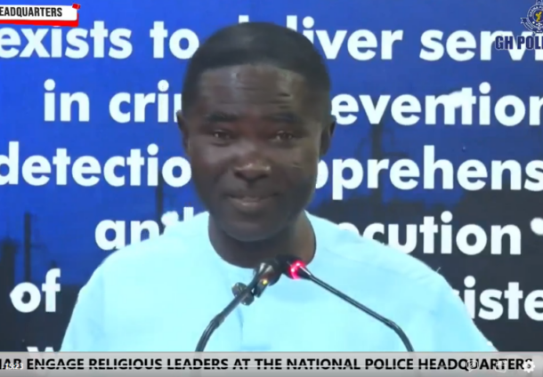

3rd Lead

Oct 1

import ban

Targets

Vehicles

15 years & older
Story: Edinam Djaton
Ghana Standards Authority (GSA) will prohibit the importation of used vehicles that are more than 15 years old from October 1, 2026, under a revised framework for enforcing national vehicle standards.
The revised threshold replaces an earlier requirement that would have barred used vehicles more than 10 years old from entering Ghana from the same date.
In a statement issued on Friday, August 14, 2026, the Ghana Standards Authority said the new framework follows extensive engagements with stakeholders and forms part of the implementation of the Ghana Standards for imported used vehicles.
The Authority said vehicles falling within specified categories “shall be prohibited from importation into Ghana”.
These include vehicles that have been submerged in water or damaged by floods, burnt or damaged by fire, or have broken, cracked, bent or twisted chassis or safety cages.
Vehicles assembled from spare parts, those without speedometers displaying readings in kilometres per hour, and vehicles more than 15 years old will also be barred.
The Authority stated that the notice supersedes its previous communication on the subject.
From October 1, used vehicle importers, distributors and dealers will have to ensure that vehicles meet Ghanaian standards before shipment to Ghana, rather than waiting until the vehicle arrives in the country.
The Authority said all used vehicle units must be inspected in their country of origin by a GSA-approved third-party inspection body, which will issue a Certificate of Conformity (CoC) confirming that the vehicle meets the applicable Ghana Standards.
“Vehicles that do not meet the prescribed requirements will not be permitted for importation into the country on arrival,” the Authority warned in the statement.
New vehicle manufacturers and assemblers, meanwhile, will be required to register with the GSA, while all new vehicle models must undergo homologation before being imported.
The Ghana Standards Authority also in the statement required new vehicle importers, distributors, manufacturers and assemblers, as well as used vehicle importers, distributors and dealers, to register with its Vehicle Homologation Unit.
The revised 15-year threshold gives importers more room than the earlier 10-year proposal, potentially keeping a wider range of used vehicles eligible for the Ghanaian market.
However, the new regime represents a significant shift in the way used vehicles are sourced and shipped into Ghana.
Importers will have to verify compliance at the point of purchase and export, reducing the risk of shipping vehicles that could later be rejected at Ghanaian ports.
For consumers, the policy could improve the quality and safety of vehicles entering the market by keeping out severely damaged, structurally compromised and excessively old vehicles. It could also reduce the risk of buyers paying for vehicles that cannot legally be cleared into Ghana.
The tighter standards could, however, narrow the pool of eligible used vehicles and potentially increase sourcing costs for dealers, particularly if inspections, certification and compliance requirements add to the cost of bringing vehicles into the country.
The Ghana Standards Authority said the framework was intended to ensure that vehicles entering Ghana comply with national standards and encouraged stakeholders to “familiarise themselves with the applicable requirements” and take the necessary steps to ensure compliance before importing vehicles.
The GSA clarified that the October 1 enforcement date will not affect vehicles shipped before October 1, even if they arrive in Ghana after the implementation date.
Similarly, vehicles already shipped and in Ghana before October 1 will be exempt from the new import requirements.
This gives importers a limited window to adjust sourcing and shipping decisions before the new regime takes effect.
The GSA’s latest notice therefore signals that the focus from October will be on pre-shipment compliance, making it increasingly important for dealers to establish a vehicle’s age, condition and conformity status before committing funds and arranging shipment to Ghana.
The move is expected to reshape the used vehicle trade by putting greater responsibility on importers and exporters to ensure that vehicles meet Ghana’s standards before they leave their country of origin.


4th Lead

Ghanaian

Evacuee

Dies

Arriving

In Accra

Story: Kukua Snead-Michaels
A Ghanaian national evacuated from South Africa as part of a government repatriation exercise has died shortly after arriving at the Accra International Airport.
The Ministry of Foreign Affairs said the deceased was among 50 Ghanaians who arrived in Ghana aboard an Air Tanzania flight at 5:50 p.m. on Friday, August 14, 2026.
According to the Ministry, the passenger’s health condition began to deteriorate about 30 minutes before the aircraft touched down in Accra.
A medical emergency team stationed at the airport attended to the passenger immediately upon arrival and attempted to stabilise the condition.
However, the Ministry said all efforts to save the passenger proved unsuccessful, with doctors confirming the death at 6:55 p.m.
In a statement issued on Friday, the Ministry said it was undertaking the necessary formalities to inform the deceased’s family.
It added that the remains had been deposited at the Police Hospital for autopsy.
The Ministry said it would provide further information on the circumstances surrounding the death after engaging formally with the bereaved family.
The deceased was part of a government-organised evacuation of Ghanaians from South Africa, although the statement did not disclose the circumstances that necessitated the evacuation or the identity of the deceased.


Editorial
A national shame: Ending the silent tragedy of maternal mortality in Ghana
NO woman should have to trade her life to give life. Yet, across the length and breadth of Ghana—from the overcrowded corridors of our urban teaching hospitals to the under-resourced CHPS compounds in our most remote districts—mothers continue to die from preventable childbirth complications. This is not merely a public health crisis; it is a national tragedy and a profound moral failure.

DESPITE years of policy frameworks, international commitments, and public health campaigns, Ghana’s maternal mortality rate remains stubbornly high.

EVERY statistic represents a human life, a mother whose absence leaves a family shattered, children orphaned, and a community impoverished. We must ask ourselves the uncomfortable question: why, in the twenty-first century, are Ghanaian women still dying of hemorrhage, hypertensive disorders (eclampsia), sepsis, and unsafe abortions?
THE answers are neither mysterious nor new. They point directly to systemic failures within our healthcare delivery architecture which include infrastructure deficit, referral trap, human resource imbalances and financial and logistics barriers

DESPITE the Free Maternal Health Care policy under the National Health Insurance Scheme (NHIS), out-of-pocket expenses for crucial drugs and lab tests continue to deter vulnerable women from seeking timely care.

WE cannot continue to issue sympathetic press releases while burying our mothers. Words will no longer suffice; systemic action is imperative.

FIRST, the Ministry of Health and the Ghana Health Service must prioritize the immediate upgrade of regional and district health centers to handle comprehensive emergency obstetric care. Every district hospital must have an operational theater, a reliable supply of safe blood, and a dedicated ambulance.

SECOND , we must overhaul the NHIS reimbursement mechanism to ensure that healthcare providers receive prompt payments. This will eliminate the hidden costs currently shifted onto pregnant women.

FINALLY, healthcare equity must be non-negotiable. Incentives must be created to attract and retain skilled health professionals in underserved rural communities.

THE measure of a nation’s development is not found solely in its GDP growth or infrastructure projects, but in how it protects its most vulnerable. Ensuring that every Ghanaian woman survives pregnancy and childbirth is a fundamental human right. It is time for government, civil society, and health administrators to treat maternal mortality as the urgent national emergency that it is.

OUR mothers have waited long enough. We must act now.

News Extra-Page2
COKA leads NPP in Ashanti region
Odeneho Kwaku Appiah popularly known as COKA has been elected Chairman of the New Patriotic Party (NPP) in the Ashanti Region after securing a landslide victory in the party’s regional executive elections.
He polled 663 votes to defeat his closest challenger, former Environmental Protection Agency (EPA) Chief Executive Officer Henry Kwabena Kokofu, who obtained 269 votes.
The decisive outcome came despite expectations of a closely fought contest between the two candidates.
In his victory remarks, Odeneho Kwaku Appiah expressed gratitude to the delegates for their confidence in him and called on party members to remain united following the elections.
He also urged supporters to celebrate the victory with restraint and humility as the party begins the next phase of its reorganisation in the region.
This was his third attempt after losing to the former Regional chairman, Benard Antwi-Boasiako, popularly known as Chairman Wontumi, on two occasions.
Ten other executives were elected to various positions to serve alongside the new Regional Chairman.
Chairperson of the Elections Committee, Rita Asobayire, commended delegates for maintaining peace and order throughout the electoral process.
The newly elected executives are expected to lead the NPP’s mobilisation and restructuring efforts in the Ashanti Region as the party prepares for the 2028 general elections.


TEWU issues 14-day ultimatum to gov’t two to address grievances

Story: Rebecca Tetteh
The Teachers and Educational Workers’ Union (TEWU) of the Trades Union Congress (TUC) has raised concerns over what it describes as the persistent neglect, discrimination and unfair treatment of non-teaching staff within Ghana’s education sector.
The union says non-teaching workers in the Ghana Education Service (GES), public and technical universities and other educational institutions continue to face a number of challenges, including delayed payment of remuneration, unfair labour practices, inadequate recognition, limited opportunities for career progression and poor working conditions.
In a circular issued on Friday, August 14, TEWU said the situation had created growing frustration among its members and could undermine industrial harmony within the education sector if urgent steps were not taken to resolve the grievances.
The union said its concerns were grounded in the provisions of the Labour Act, 2003 (Act 651), arguing that some of the practices confronting its members amount to unfair labour practices.
TEWU stressed that non-teaching staff remain an essential component of Ghana’s education system and should not be treated as less important than other categories of workers.
The union outlined eight key demands it wanted the relevant authorities to address as part of efforts to resolve the concerns of non-teaching staff and maintain industrial peace.
One of the major demands concerns the non-payment of overtime allowances owed to watchmen and security personnel within the Ghana Education Service.
TEWU demanded the prompt payment of all outstanding overtime allowances that have accrued over the years.
TEWU also raised concerns over what it described as intended changes to university statutes that could affect the union’s representation on governing councils of universities and colleges of education.
TEWU therefore issued a two-week ultimatum to the relevant authorities to resolve the concerns and demands of its members.
“By this statement, we are serving two (2) weeks’ notice, effective today, 14th August 2026, on the various stakeholders (the Minister of Finance, the Minister of Education, GTEC, university managements, GES Management, etc.) to address our concerns accordingly.
“Failure to address the above issues will compel members of TEWU to advise themselves accordingly.”

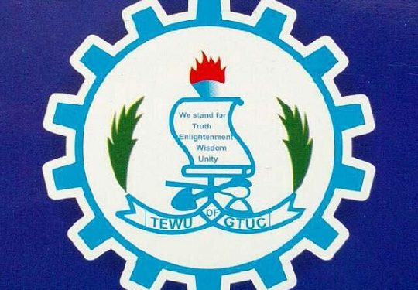

International news-Page4

Peru cracks down on illegal gold mining in Amazon reserve with military show of force

The skies above a rich corner of the Peruvian Amazon filled with smoke and debris this week as all branches of the country's military attacked illegal gold mining camps deep in the jungle.
Teams of soldiers on Tuesday stormed Tambopata National Park, a spot in the Peruvian Amazon in the southeastern Madre de Dios region visited by an average of 40,000 tourists per year. ABC News documented countless gold mining camps along the Tambopata river, which was home to a rich rainforest a few years prior.
The mining camps have become small villages or even towns, with fully functioning bars, makeshift restaurants and brothels accused of sex trafficking. The alleged miners were seen fleeing the scene as the military arrived, sprinting deeper into the Amazon and leaving behind women and a child.
Members of the military escorted the women and the child off the premises for questioning, all of whom were eventually released and taken back to the nearest town, Puerto Maldonado. The large-scale equipment, boats, campsites were lit ablaze or rigged with dynamite and detonated by the officials.
This military operation is a sequel. Dubbed Operation Mercury 2, this effort comes seven years after the first campaign proved to be temporarily effective, with a 90% drop in mining that eventually grew back to surpass previous numbers, according to the Monitoring of the Andes Amazon Program (MAAP).
Gold mining has ravaged large parts of the Amazon that spans multiple countries, including Ecuador, Brazil, Colombia and Peru -- driven by the global rise in gold prices.
Since the first Operation Mercury in 2019, the price of gold has more than tripled globally, rising from an average of about $1,394 an ounce that year to roughly $4,395 an ounce today -- an increase of about 215%. The soaring price has made extracting even small amounts of gold increasingly lucrative.
Gold mining's environmental footprint has become enormous: by mid-2025, gold mining had destroyed nearly 344,000 acres of the Peruvian Amazon, according to MAAP, with 97.5% of that deforestation in Madre de Dios.
Mining has now spread across nine regions of the Peruvian Amazon and has been documented in 225 rivers and streams. While the mines themselves trample landscapes, the mercury used in the process is poisoning communities.
Peru's special forces commence Operation Mercury II.Osej Serratos for ABC News
A 2021 study of communities in Madre de Dios found that 71% of people living within mining communities and 80% of people living outside mining communities had hair-mercury concentrations above the U.S. EPA reference level.
Researchers linked fish consumption to higher mercury levels. Several types of fish have been banned from consumption in the area given their mercury levels, but most fish markets do not abide by these laws.
"This week is just the beginning of Operation Mercury 2 to remove all illegal gold miners from within Tambopata National Park and build a robust, long-term muti-agency presence to prevent their return," said Ronal Ramón Flores Ñañez, provisional deputy supreme prosecutor, who accompanied the military on the operation.
Smoke rises throughout Tambopata National Park as authorities push in to ambush illegal gold miners.ABC News
Tambopata National Park is just one of six endangered national parks in Peru where illegal mining is destroying hundreds of square miles of federally protected areas -- many are UNESCO World Heritage sites.
This operation is being partly funded by Global Conservation, an international nature conservation group whose mission is the direct protection of endangered national parks and indigenous territories in developing countries.
"Illegal gold mining in national parks is crossing the Red Line for Peru's government," said Jeff Morgan, executive director of Global Conservation. "We are launching Operation Mercury 2 together to show the world Peru will no longer allow illegal mining in their national parks, polluting the rivers and water supplies for hundreds of thousands of people and wildlife; causing death and sickness for the next hundred years."
ABC News has partnered with Global Conservation to develop "Last Lands," a series that documents national parks around the world in need of aid.
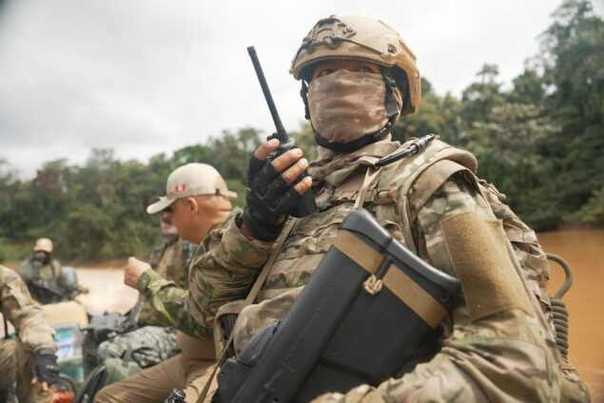

Liechtenstein changes succession rule to allow women to ascend the throne
Liechtenstein has announced that it has changed royal succession rules to allow women to ascend the throne.
The declaration was made on the national day of the central European country, which has a population of just 44,000.
Liechtenstein's current ruler, Prince Hans-Adam II, has been the head of their royal family since 1989. The rule change will not affect his heir, Hereditary Prince Alois, who was his first-born.
Alois has carried out most official royal duties for the last two decades.
"The order of succession is being changed from male primogeniture to absolute primogeniture," the House of Liechtenstein said in a statement.
"This means that in future the first-born child, regardless of sex, will become heir to the throne and later princess or prince of Liechtenstein."
The change will not affect Liechtenstein's succession line for now - it will only apply to descendants of the four children of Hereditary Prince Alois and his wife, Hereditary Princess Sophie.
In a statement, Alois said: "With this change in the law, we want to ensure that both the Principality of Liechtenstein and the Princely House are led by the person who has been best prepared for this responsibility."
Liechtenstein is a tiny, doubly-landlocked country tucked away between Switzerland and Austria, whose ruler enjoys sweeping political powers, unlike many of his counterparts in Europe.
In 2011, Britain changed its succession laws to allow first-born daughters of a monarch to inherit the throne.
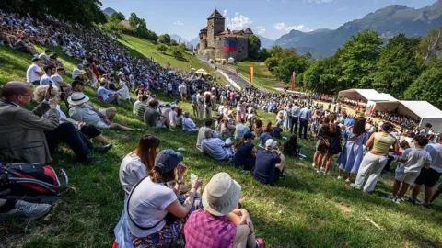

Morocco detains dozens of migrants trying to cross into Ceuta- reports
Moroccan authorities have intercepted dozens of migrants seeking to cross into the Spanish North African exclave of Ceuta, reports say.
More than 100 people were blocked trying to make their way to the border on the outskirts of the town of Fnideq, according to Moroccan security sources cited by Spanish media and the Reuters news agency.
It comes a fortnight after roughly 78,000 migrants arrived in the exclave by sea in a matter of hours - 100 of whom died, according to the city's mayor, who also said the vast majority of arrivals had returned to Morocco.
Security had been stepped up in the area after the influx and amid suggestions on social media of a second mass crossing attempt this weekend.
The security sources said 111 people had been detained in or around Fnideq - known in Spanish as Castillejos - about 3km (1.8 miles) from the border, the majority of whom were from sub-Saharan Africa.
Moroccan police - including some in riot gear - reportedly used tear gas to disperse groups of migrants gathered on nearby hills.
Earlier this week, Morocco's government said it was monitoring "the circulation of social media posts and messages of unknown origin" calling for a mass crossing on Saturday, and warned that it would prosecute organisers and participants.
Security at the breakwater entrance was "10 times stronger than the previous day", Spanish newspaper El País reported.
Morocco had dispatched army officers, navy speedboats and drones to the border on Saturday, it said.
Madrid meanwhile deployed more than 1,500 security officers to patrol the area.
Spain has also installed a metal fence and a floating barrier following last month's influx.
The crisis had calmed since breaking out in late July, but it has sparked tensions between EU nations which share open borders as well as criticism of the Spanish government.
Italy suspended the 29-member Schengen arrangement of free movement with Spain and introduced border checks on arrivals from Spain.
Italy was backed by Finland and Denmark, while the Czech Republic called for Spain's membership to be temporarily suspended.
Spain reacted angrily, with Prime Minister Pedro Sánchez noting Ceuta was not part of the Schengen area - and the migrants, therefore, had not arrived on the Spanish mainland and could travel to any other European country.
It urged Italy to drop its border controls - and introduced its own when Rome refused, citing the possibility of a new influx on 15 August.
On Saturday, Italy's Foreign Minister Antonio Tajani said his country had been afraid of a "risk of a new wave of arrivals in Ceuta".
"We're not waging any kind of 'battle' against Spain; we're simply carefully controlling arrivals," he said.
"Instead of worrying about us, Spain should worry about Morocco: that's where the problems are coming from, certainly not from our controls."
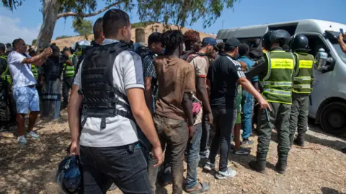

Business-Page 5

AGI demands actionable policy for 24-hour economy

Story: Kukua Snead-Michaels
Chief Executive Officer of the Association of Ghana Industries (AGI), Seth Twum Akwaboah, has urged government to move beyond slogans and focus on the concrete policies and programmes needed to make Ghana’s 24-Hour Economy work.
He said the success of the policy should not be measured by the popularity of its name but by the practical steps taken to change the status quo.
“For me, I don’t bother so much about the clichés you create, whether it is 24-Hour Economy or 1D1F; that’s not really the issue for me. It is more of what you do within those policies,” he said.
Mr Akwaboah said government must pay particular attention to how policies are developed and implemented.
“You can come up with any policy, but then, when you develop the policy, what has gone into the policy development? How consultative was its nature? What are the key policies or activities within the policy that you are trying to implement to change the status quo?” he asked.
His comments come as the government continues efforts to operationalise its flagship 24-hour economy policy, which is intended to expand economic activity beyond traditional working hours and create more opportunities for businesses and workers.
The AGI President acknowledged that the policy was initially unclear, leading to questions from businesses and other stakeholders.
He, however, said consultations with government had helped bring greater clarity to the initiative.
“I think we are making good progress because now it’s coming clearer. Governmentis defining,” he said.
Mr Akwaboah cautioned against expectations that the policy would transform the economy overnight.
“When you hear a cliché, when you hear a mention of something like that, sometimes the expectation is that overnight things will change and everything will be a 24-hour economy. It doesn’t happen like that,” he explained.
He compared the situation to the former government’s One District, One Factory (1D1F) initiative.
“The same thing I said is that when we had the 1D1F. All of a sudden, you think that every district is going to have an industry? Government has mentioned it. It’s an intention. It’s a vision. How do we work towards it?” he said.
According to him, the focus should now be on identifying the specific interventions needed to make the 24-hour economy a reality.
“But then we need to define the specific activities and policies and programs we are going to do to make that happen,” he said.
Mr Akwaboah said government had made progress by launching a blueprint for the initiative, which he believed contained ideas capable of transforming economic activity if properly implemented.
“And gradually they are coming to that point where now they’ve launched a blueprint, and then in it there are a lot of interesting ideas. If we’re able to implement it to the letter, I’m sure it will help change a lot of things,” he said.
He reaffirmed the AGI’s support for the policy and said the association was already engaging the 24-hour economy secretariat on its implementation.
“So for me, I embrace it just as we embraced the 1D1F, AGI embraces the 24-hour economy, and we are working with government,” he said.
“We are working with the 24-hour economy secretariat to implement some of the things they said they will implement. If we’re able to do it, it will be a game changer,” he added.

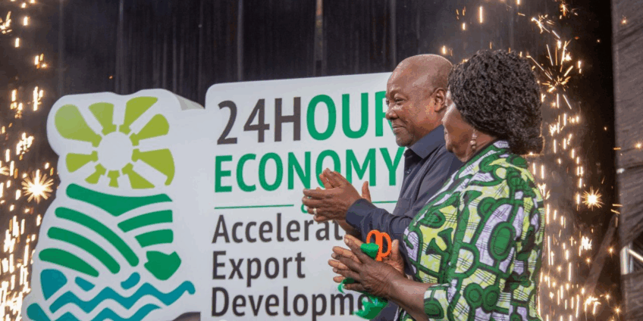

Don’t buy cocoa on credit -COCOBOD warns LBC

Story: Business Desk
The Ghana Cocoa Board (COCOBOD) has warned Licensed Buying Companies (LBCs) against purchasing cocoa beans from farmers on credit, with repeat offenders facing the possibility of losing their operating licences.
COCOBOD Chief Executive Officer, Dr Randy Abbey, said the directive was part of efforts to improve liquidity in the cocoa purchasing system and ensure farmers receive prompt payment for their produce.
He said the regulator had formally communicated the new position to LBCs and also advised farmers not to hand over cocoa beans without receiving payment.
Dr Abbey said the restriction was necessary because delays in financing have hindered LBCs' ability to purchase cocoa efficiently, leaving some companies heavily indebted to financial institutions.
“The arrangement is to aid the shorter turnaround time for LBCs so that it can quicken the pace of purchases, eliminate indebtedness to banks and improve the efficiency and profitability of cocoa purchases,” he said.
Speaking at the launch of the Chamber of Cocoa Marketers, Dr Abbey explained that COCOBOD was not immediately withdrawing any licences because of past breaches.
However, companies that disregard the directive in future could face sanctions, including the revocation of their licences.
“We are not withdrawing anybody’s license. But we have written to the effect that if it happens again, your license will be revoked because it is against the terms of your license,” he said.
He also urged farmers to comply with the directive by refusing to sell their cocoa on credit.
“We have also told the farmers that LBCs are not supposed to buy cocoa on credit from you. So don’t go and take your cocoa to any purchasing clerk on credit,” he added.
The directive comes ahead of the implementation of a new financing arrangement for cocoa purchases from the 2026/27 crop year.
Dr Abbey said the model was expected to provide adequate funding for cocoa procurement and related activities throughout the year, reducing delays in payments to LBCs after they take over cocoa receipts from farmers.
“The new funding model is to ensure sufficient liquidity for cocoa purchases and related operations all year round,” he said.
“Hence, beginning the 26/27 crop year, we hope to eliminate the delays in the payment of cocoa taking over receipts, which have been the bane of LBC since 2020.”
According to the COCOBOD CEO, improving payment speed would enable LBCs to purchase cocoa more quickly, reduce their exposure to bank debt, and improve the profitability of cocoa marketing.
He added that the financing reforms would also support efforts to expand local cocoa processing and value addition by improving domestic processors' access to cocoa beans.
Dr Abbey said the reforms formed part of the broader changes introduced under the Ghana Cocoa Board Bill 2026, which he said guarantees farmers 70% of the gross Free On Board value while allowing producer prices to be reviewed during the season based on market developments.
“These measures and the new bill constitute the most significant reforms to our industry since 1984,” he said. “These reforms are resetting the cocoa sector for growth and industrialisation.”
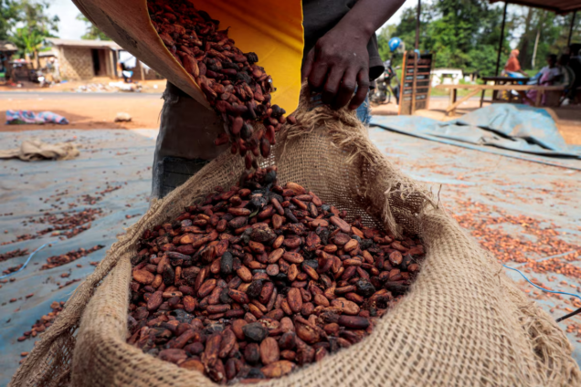

Ghana-Nigeria trade dispute ends

Story: Reuben Sackey
The Accra Onion Sellers and Importers Cooperative Society, together with the Cross Border Women Traders Association, has commended the Minister for Trade, Agribusiness and Industry, Elizabeth Ofosu-Adjare, for her swift intervention in resolving the recent trade dispute between Ghana and Nigeria’s onion traders.
The commendation follows the lifting of the suspension placed on onion exports to Ghana by the National Onion Producers and Marketers Association of Nigeria, a move that has restored the flow of onion supplies between the two neighbouring countries.
The cooperative society, which comprises five major onion sellers’ associations, including the Accra and Adjei Kotoku groups as well as the Dominanse Association in the Central Region, praised the Minister and her officials for their timely engagement with stakeholders to address the concerns affecting traders on both sides.
At a meeting held in Accra on Wednesday, August 12, 2026, involving representatives from Ghana and Nigeria, Elizabeth Ofosu-Adjare, called for an immediate end to the dispute, emphasising the importance of strengthening trade relations between the two countries and promoting economic cooperation within the ECOWAS sub-region.
The minister appealed to all stakeholders to put their differences aside and work together to create a more stable and mutually beneficial trading environment.
She cautioned that a prolonged disruption in onion trade could negatively affect farmers, traders, transport operators and consumers in both Ghana and Nigeria.
Following the intervention, all four Ghanaian trucks transporting onions from Nigeria to Ghana had been released as of Thursday, August 13, 2026, according to the Public Relations Officer of the Accra Onion Sellers and Importers Cooperative Society Mr. Osman Mohammed.
The society also confirmed that all Nigerian trucks carrying onions that had arrived in Ghana had completed offloading their produce at various markets across the country.
The traders expressed confidence that the minister’s intervention would pave the way for a lasting solution and stronger collaboration between Ghanaian and Nigerian traders, while contributing to the growth of agricultural trade within the ECOWAS region.

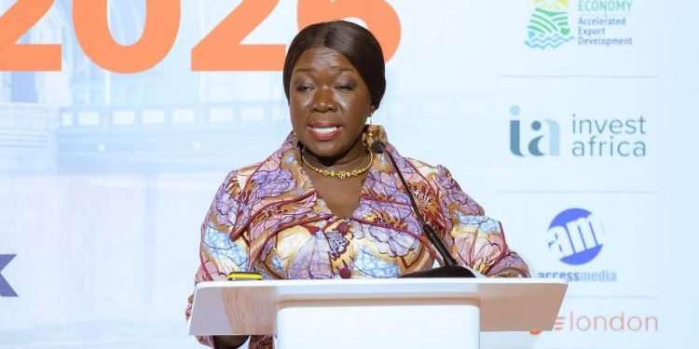

Locals -Page 6& 7

Tourism Minister mandates clearance of illegal structures surrounding heritage sites

Story: Vida Wiafe
The Minister for Tourism, Culture and Creative Arts, Dzifa Gomashie, has called for the immediate removal of unauthorised structures around Ghana’s forts and castles, warning that continued encroachment threatens the preservation of the country’s cultural heritage.
She said some heritage sites were facing severe pressure from illegal developments, including structures built within areas intended to serve as protective buffers around the historic monuments.
Speaking at a symposium on the Korea-Ghana Heritage Project in Accra, Ms Gomashie said efforts to remove the structures must go hand in hand with sustained engagement with communities living around the heritage sites.
According to her, residents were more likely to support preservation efforts when they understand the historical and cultural significance of the monuments.
“Often, we leave out the engagement with the community. And so they don’t see the importance of why our, for example, call for the demolition of illegal structures around the forts and castles,” she said.
The Minister said the extent of encroachment around some of the sites had become alarming and required urgent intervention.
“If I show you pictures of the encroachment on the buffer for the forts and castles, you will join me in doing Aluta,” she said.
Ms Gomashie stressed that protecting Ghana’s heritage sites could not be left to government alone.
She called for stronger collaboration among traditional authorities, local communities, relevant state institutions and other stakeholders to prevent further encroachment and safeguard the country’s forts, castles and other heritage assets for future generations.
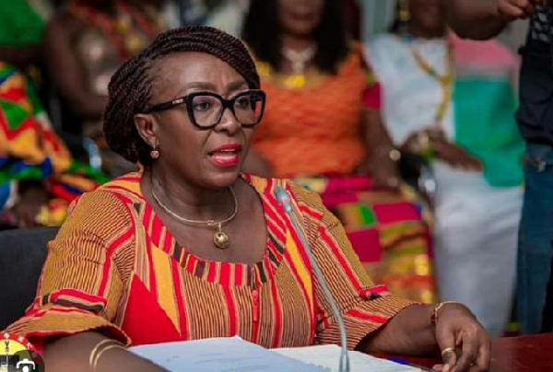

Gov’t targets 100,000 care sector jobs

Story: Yaw Takyi

The government has announced to launch a domestic care economy programme next year, with Youth Development Minister George Opare-Addo projecting that the initiative will create about 100,000 jobs.
According to Mr Opare-Addo, the programme forms part of the government’s broader strategy to tackle unemployment, particularly among young people, as Ghana continues to experience rapid growth in its youth population.
He said although recent data from the Ghana Statistical Service indicated an overall decline in unemployment, youth unemployment remains a concern because of the large number of young people entering the labour market.
“When the Ghana Statistical Service put out their figures, you see that unemployment has generally come down, and it means that our policies are working, but you will also see that there is a small increase in youth unemployment, and the reason is that the youth bulge is big and that is where our population is growing,” he said.
Mr Opare-Addo said the planned care economy programme would create employment opportunities while responding to the growing demand for domestic and care-related services.
He explained that the initiative would form part of a wider package of youth-focused interventions intended to create sustainable livelihoods and reduce pressure on the formal job market.
The Minister said the government would continue to roll out targeted employment programmes to ensure that Ghana’s growing youth population becomes an economic asset rather than a source of increasing unemployment pressure.
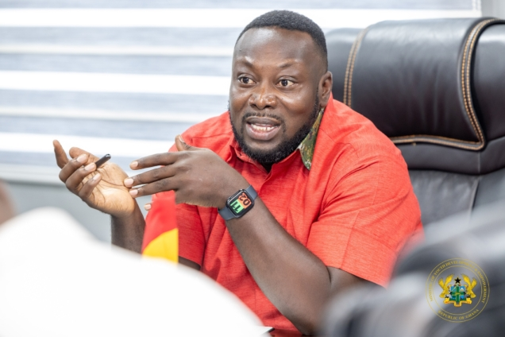

Religious Affairs Ministry creates central registry for shrines, religious sites

Story: News Desk
The Ministry of Local Government, Chieftaincy and Religious Affairs has begun efforts to build a national database of shrines, religious sites and their operators as part of measures to improve regulation, planning and recognition of traditional and faith-based institutions.
The Ministry has therefore urged traditional authorities and practitioners to cooperate with the exercise to ensure accurate documentation of Ghana’s spiritual and cultural heritage.
Chief Registrar at the Ministry, Baafi Nsiah, made the appeal at a mass registration, licensing and sensitisation programme for traditional, indigenous and faith-based healing practitioners in the Ashanti Region.
He said the exercise was necessary to help the government understand the scope and nature of traditional and faith-based practice across the country.
“There is no cause for alarm. The aim is simply to determine the number of shrines and other religious sites nationwide. We will therefore need the cooperation of traditional authorities and practitioners to ensure accurate data collection,” he said.
Mr Nsiah acknowledged that identifying and documenting shrines could be complex because some are housed in permanent structures while others are located at natural sites.
He said the database would also help identify shrines and religious sites with historical and cultural significance that could be developed as tourist attractions.
According to him, this would help preserve Ghana’s spiritual heritage while creating opportunities for education and tourism.
“Beyond documentation, we want to protect these spaces and use them as avenues to promote our culture and heritage to the next generation,” he said.
Mr Nsiah added that the Ministry would work with traditional authorities, tourism stakeholders and local assemblies to ensure that selected sites are properly conserved and presented in a manner that respects their sanctity.
The event was organised by the Trado-Afrikan Faith Healers Association in collaboration with the Ministry of Local Government, Chieftaincy and Religious Affairs and the Traditional Medicine Practice Council.
Held at the Kumasi Centre for National Culture, the programme was on the theme: “Building a Recognised and Regulated Traditional Healing Sector in Ghana.”
Hundreds of practitioners attended to register, receive licences and be sensitised on regulatory requirements and best practices.
Participants welcomed the initiative, describing it as an important step towards greater recognition, regulation and legitimacy for practitioners who have historically operated outside formal structures.
Registrar and Chief Executive Officer of the Traditional Medicine Practice Council, Dr Yakubu T. Yusuf, said the registration and licensing exercise formed part of the government’s broader efforts to formalise and regulate the traditional healing sector.
He said the process was intended to protect public health, eliminate unqualified practitioners and support the proper integration of traditional medicine into the national healthcare system.
Dr Yusuf cautioned that practising without a valid licence was an offence under the Traditional Medicine Practice Act.
He said offenders could face a fine of up to 500 penalty units, a prison term of up to two years, or both.
“We are not here to witch-hunt anyone. Our goal is to recognise legitimate practitioners, give them legal backing, and ensure that the services they provide are safe for the public,” he said.
He urged traditional and faith-based healers who are yet to register to take advantage of the ongoing exercise to regularise their practice.
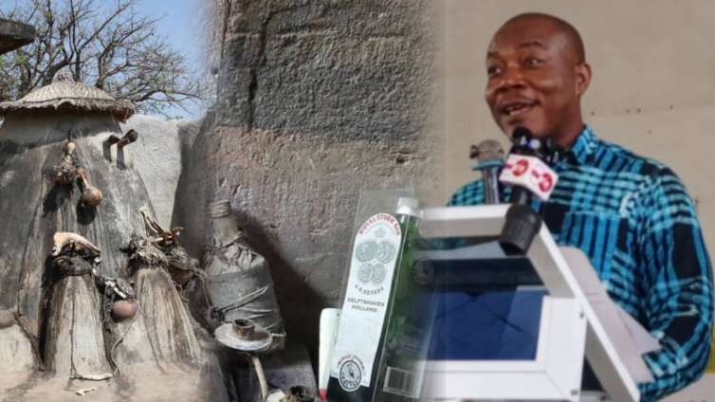

Reforms must make staff welfare priority – Civil Service head

Story: News Desk

The Head of the Civil Service, Dr Evans Aggrey-Darkoh, has called for greater attention to staff wellbeing, teamwork and discipline as part of efforts to improve performance across the public sector.
He said activities that promote healthy living, interaction and teamwork can help reduce workplace pressure and strengthen cooperation among public servants.
Dr Aggrey-Darkoh made the call at the end of a cooking competition and health fair organised for staff of various ministries as part of activities marking Civil Service Week.
The annual service-wide programme is coordinated by the Office of the Head of the Civil Service and involves ministries and departments across the country.
This year’s celebration was on the theme: “The Resetting Agenda for Sustainable Development in Ghana: The Civil Service’s Responsibilities.”
Dr Aggrey-Darkoh said the activities provided an opportunity for staff to relax, interact and work together outside their usual office environment.
“From time to time we need to organise things like these. People are under pressure. Today I saw people dancing, networking, and working as a team. That spirit is what we need to drive the Service forward,” he said.
He urged staff to apply the same spirit of discipline, teamwork and effective time management to their daily responsibilities.
“Management of time is also an indicator of how developed a country is. Let’s manage our time very well,” he stated.
Dr Aggrey-Darkoh also stressed the importance of healthy living, noting that hygiene and food quality were key considerations in the cooking competition.
“You are as good as what you eat,” he said.
“If the food environment is not hygienic, you are literally taking poison. We must be conscious about what we consume both at work and at home,” he added.
He said the activities formed part of efforts to support the government’s reset agenda and build a public service that was more productive, resilient and enterprising.
“It should not be said that when we were in charge, we did not deliver. We need everyone on board to achieve the targets we have set for ourselves,” he said.
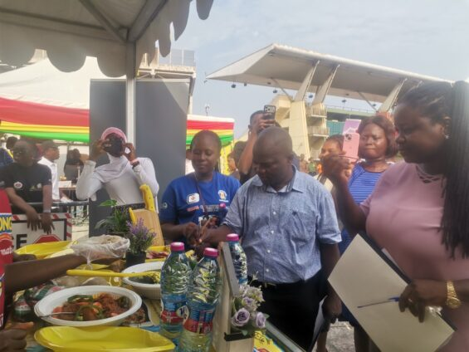

Threatening Ghana’s peace harms our children-IGP
Story: Vida Wiafe
Inspector-General of Police (IGP) Christian Tetteh Yohunu has urged religious leaders to use their influence to prevent religious tensions and violence, warning that any attack on Ghana’s peace ultimately threatens the future of the country’s children.
Speaking at an engagement with religious leaders at the National Police Headquarters on Friday, August 14, 2026, the IGP said religious leaders had a critical role to play in maintaining peace, particularly at a time when tensions could easily be inflamed by speech and actions.
He stressed that citizens must not take the law into their own hands when they believed an offence had been committed, insisting that such matters must be reported to the appropriate state institutions.
“No civilised society can survive when individuals take the law into their own hands. When a citizen believes a crime or an offence has been committed, the only righteous path is to report it to statutory authorities and trust the legal process,” he said.
Mr Yohunu also emphasised the need to protect both freedom of religion and freedom of expression, while making it clear that those freedoms do not justify violence or unlawful attacks against individuals.
“Every individual has a right to practice their faith without fear of violence,” he said.
According to the IGP, although speech that incited religious hatred was restricted under Article 20 of the International Covenant on Civil and Political Rights (ICCPR), alleged offences must still be dealt with through lawful processes.
“While speech that incites religious hatred is restricted under Article 20 of the ICCPR, due process and prohibition of extrajudicial harm, no suspect under state custody or in the public space may be subjected to torture, cruel treatment, or assault,” he said.
Mr Yohunu, therefore, appealed to Christian and Muslim leaders to use their platforms to calm tensions and discourage their congregations, particularly young people, from resorting to violence.
“Our revered clergy and the imams, our beloved chief imam, they listen to your sermons, read your social media posts, and follow your gestures,” he said.
He warned that the influence of religious leaders could either help prevent conflict or worsen tensions depending on the messages they put out.
“At this fragile moment, your words can either act as water upon an emerging fire or as petrol upon dying embers. I ask three key commitments from you today. Dedicate your Friday sermons in Islam and Sunday sermons strictly to messages of interfaith harmony, self-control, and the danger of religious conflict,” he urged.
He also asked religious leaders to remind their congregations of the wider consequences of violence, particularly for future generations.
“Remind your congregations that an attack on the peace of Ghana is an attack on the future of their own children,” Mr Yohunu said.
He further called for visible cooperation between Christian and Islamic leaders as a way of demonstrating unity to the public and countering attempts to turn religious differences into sources of conflict.
“ Let the public see Christians and Islamic leaders standing together, sharing meals, issuing joint statements, and walking through our communities hand-in-hand,” he said.
The IGP said such cooperation was particularly important in reaching young people, who could be influenced by messages portraying religious differences as grounds for division.
He urged religious leaders to teach their congregations that reporting alleged offences to the appropriate institutions, rather than seeking personal or communal retaliation, was consistent with both responsible citizenship and religious values.
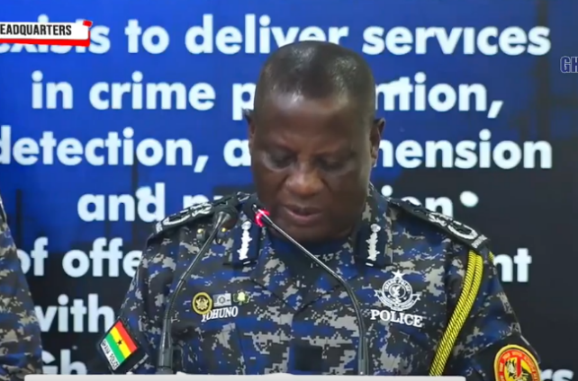

Oppong Nkrumah challenges CJ

*At Supreme Court over legal vacation policy

Story: News Desk

Ofoase-Ayirebi Member of Parliament (MP), Kojo Oppong Nkrumah, has invoked the original jurisdiction of the Supreme Court, challenging directives from the Chief Justice that require selected judges to sit during the legal vacation to hear designated criminal cases.
In a writ filed at the Supreme Court in 2026, Mr Oppong Nkrumah is seeking declarations that the Chief Justice’s decision to direct some judges to conduct criminal trials involving selected cases during the legal vacation is inconsistent with several provisions of the 1992 Constitution and should therefore be declared unconstitutional, null and void.
The action has been brought against the Chief Justice of the Republic of Ghana and the Attorney-General.
Mr Oppong Nkrumah is relying on Articles 2(1) and 130(1) of the Constitution, together with Rule 45 of the Supreme Court Rules, 1996 (C.I. 16), as the legal basis for invoking the apex court’s original jurisdiction.
At the heart of the case is the Plaintiff’s contention that the arrangement for hearing selected criminal matters during the legal vacation raises questions about equality before the law, administrative discretion, access to justice and the rights and welfare of members of the legal profession and judicial service.
According to the writ, Mr. Oppong Nkrumah wants the Supreme Court to determine whether warrants issued by the Chief Justice directing certain judges to sit during the legal vacation for the conduct of criminal trials in selected cases are compatible with Articles 17(1) and (2), 23 and 296(a) and (b) of the Constitution.
The MP argues that the Constitution guarantees equality before the law and protection against discriminatory treatment, and he asks the Supreme Court to examine whether the selection of particular cases for hearing during the legal vacation constitutes unequal treatment.
A major aspect of the case concerns what the legislator describes as “selective justice.”
Mr Oppong Nkrumah is asking the Supreme Court to declare that prioritising what have been described as “special criminal cases” for hearing during the legal vacation, while other criminal matters are left unattended, violates Article 17(1) of the Constitution.
He is therefore seeking a declaration that the practice, if found to have the effect alleged in his writ, is unconstitutional, null and void.
The Plaintiff has also raised concerns about the impact of the directive on the health and welfare of members of the Ghana Bar and the Judicial Service who are affected by the decision to conduct proceedings during the legal vacation.
He is asking the Supreme Court to determine whether the Chief Justice’s directives are inconsistent with constitutional provisions relating to the right to work under satisfactory, safe, and healthy conditions and the broader constitutional obligation to protect workers' welfare.
Specifically, Mr. Oppong Nkrumah is relying on Articles 24(1) and (2) and 36(10) of the 1992 Constitution in challenging the directives.
The case further seeks to subject the relevant court rules to constitutional scrutiny.
Mr. Oppong Nkrumah is asking the Supreme Court to declare that Order 79 Rules 1(1) and 2 of the High Court (Civil Procedure) Rules, 2004 (C.I. 47), to the extent that they permit the Chief Justice to select cases for hearing during legal vacations in the same manner as ordinary court sittings, are inconsistent with Articles 17(1), 17(2), 23, 24(1), 24(2), 36(10) and 296(a) and (b) of the Constitution.
If the Supreme Court agrees with the Plaintiff’s interpretation, the affected provisions would be rendered constitutionally unenforceable to the extent challenged.
The MP is also asking the Supreme Court for any other orders or directions it considers necessary to give effect to whatever declarations the court may ultimately make.
Mr Oppong Nkrumah has brought the case in multiple capacities—as a Ghanaian citizen, a Member of Parliament and a lawyer—underscoring the constitutional nature of the challenge.
The writ directs the two defendants to file their respective statements of case within 14 days after service of the Plaintiff’s case, inclusive of the day of service.
The lawsuit comes against the backdrop of growing public and legal debate over how criminal cases are prioritised within the justice system, particularly where special arrangements are made for certain cases.
The legal vacation is ordinarily a period during which the regular activities of the superior courts are reduced, although the applicable rules permit arrangements for certain matters to be heard during the period.
The dispute raised by Mr Oppong Nkrumah is therefore not simply about whether courts can sit during the vacation, but whether the manner in which particular cases are selected and prioritised complies with the constitutional principles of equality, fairness and proper exercise of discretion.
At the centre of the constitutional challenge is also Article 296, which regulates the exercise of discretionary power by public authorities.
Mr Oppong Nkrumah is asking the Supreme Court to determine whether the Chief Justice’s exercise of administrative and judicial discretion in selecting cases for vacation sittings meets the constitutional requirements governing such discretion.
The former Information Minister’s action could consequently have implications beyond the specific criminal cases affected by the disputed directives.
A ruling by the Supreme Court could clarify the extent of the Chief Justice’s administrative powers in organising vacation sittings and the constitutional limits, if any, on the selection of cases for such proceedings.
The case also places before the Supreme Court the broader question of how the constitutional guarantee of equality before the law should operate within the administration of criminal justice where the judiciary decides that certain cases require accelerated attention.
Until the Supreme Court determines the matter, the allegations and constitutional arguments contained in the writ remain claims advanced by the Plaintiff and are subject to judicial determination.
The Chief Justice and the Attorney-General will have the opportunity to respond to the claims in their statements of case.
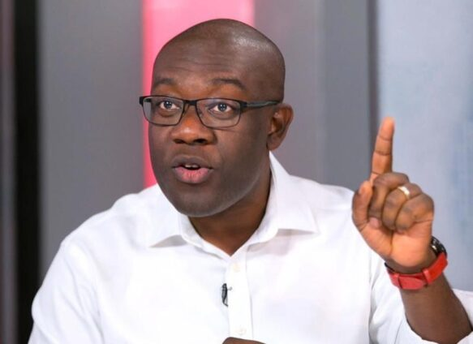

Ashanti NPP holds vigil for Wontumi
Story: Nana Kwasi Peprah
The New Patriotic Party (NPP) in the Ashanti Region has held a vigil in Kumasi in solidarity with its Regional Chairman, Bernard Antwi Boasiako, popularly known as Chairman Wontumi.
This comes as his lawyers begin processes to appeal his conviction and sentence.
Party executives, constituency leaders and supporters gathered at the DMB Campaign Office in Kumasi to express their support for the embattled chairman and demand his release.
Chairman Wontumi was sentenced to 20 years’ imprisonment with hard labour by an Accra High Court after being found guilty of involvement in illegal mining activities at Samreboi in the Western Region.
The NPP said the vigil was intended to demonstrate its solidarity with the regional chairman and mobilise members as his legal team seeks to overturn the court’s decision.
The party has maintained that it will support Chairman Wontumi through the ongoing legal process.
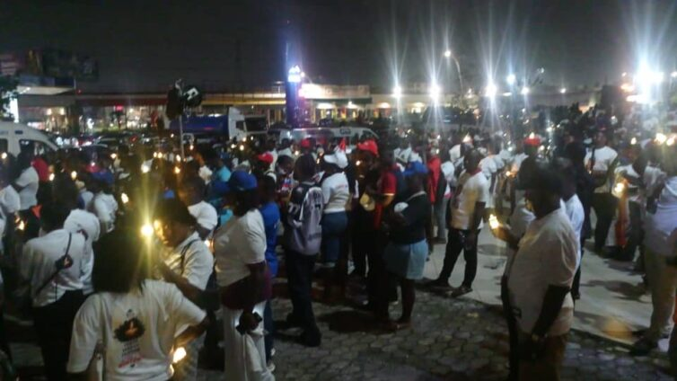

Yiidana chief, son killed in Gushegu

Story: Hamza Mohammed

A disputed chief of Yiidana and his son have been shot dead in the Gushegu Municipality of the Northern Region, reigniting a chieftaincy dispute that has persisted for nearly four years.
District Chief Executive Abdul Hafiz Adam said three gunmen attacked the chief’s family house at about midnight on Thursday.
“What happened was that yesterday, in the night, around 12:00 a.m., we had information that some gunmen had attacked the disputed chief of Yiidana. Three gunmen, as we are told, went to the house and shot him and his son. So, both of them have died, and we can confirm their deaths for now,” he said.
The killings are linked to a longstanding dispute over the authority to enskin a chief for Yiidana, involving the nearby Paboni community and the traditional authority of Zantali-Lana.
According to Mr Adam, the conflict began about four years ago when the Zantali-Lana moved to install a chief for Yiidana.
He said residents of Paboni objected and challenged the Zantali-Lana’s authority to carry out the enskinment.
The matter was subsequently referred to the Yaa Naa’s palace in Yendi.
“The Yaa Naa ruled that the Zantali-Lana had that authority to enskin a chief for that community,” Mr Adam said.
The ruling, however, did not end the dispute.
Earlier clashes between residents of Yiidana and Paboni resulted in the destruction of property. As part of efforts to resolve the matter, Yiidana was advised to seek compensation through the courts.
Mr Adam said the dispute resurfaced when the Zantali-Lana again sought to carry out the enskinment.
He said the chief with jurisdiction over Paboni later indicated that Yiidana did not fall under Paboni, effectively clearing the way for the Zantali-Lana to proceed.
Residents of Paboni reportedly attempted to disrupt the ceremony, but the enskinment went ahead.
Due to security concerns, however, the newly enskinned chief was initially made to live outside Yiidana.
About a month ago, the chief’s family informed local security authorities of plans to return him to the community.
Mr Adam said the Municipal Security Council asked the family to allow time for an assessment of the security situation.
“We, as MUSEC, requested that we should be given time to go into the matter and be able to establish that there will be enough security for the chief in the community before he relocates back to the community,” he said.
“But the family failed to listen to us. They insisted that they had already sent the chief to the Yiidana community.”
Mr Adam said local authorities eventually allowed the chief’s return on condition that peace was maintained.
That arrangement, he said, was shattered by Thursday night’s attack.
Police and military personnel have since been deployed to Yiidana.
Mr Adam said he was awaiting the arrival of the Northern Regional Minister and the Regional Security Council from Tamale to assess the situation and determine the next steps.
He said the area was currently calm.
“Currently, the place is calm. There is no fighting, there is no gunshots,” he said.
The bodies of the chief and his son remain in the community pending decisions by MUSEC and REGSEC on burial arrangements.
Despite the calm, the killings have heightened tension in the area.
Mr Adam said many residents of Yiidana and surrounding communities had fled amid fears of possible retaliatory attacks.
He said there was “general suspicion out there that the two families may attack each other again,” prompting residents to leave their communities.
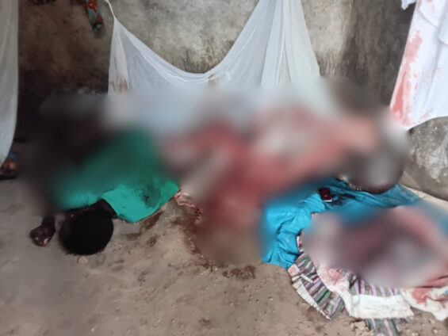

Manhyia outlaws unauthorised
Story: Nana Kwasi Peprah
Manhyia Palace has banned the unauthorised operation of drones and other unmanned aerial vehicles within the palace and its surrounding areas.
The directive, contained in a notice posted on the palace’s Facebook page on Saturday, August 15, takes immediate effect.
The palace said no drone or other aerial operation would be permitted within the designated area without prior and explicit authorisation from the palace or the relevant authorities.
It warned that any unauthorised drone flight would result in the confiscation of the equipment involved.
Operators who violate the directive could also face legal action, the palace cautioned.

The palace therefore urged drone operators to obtain the necessary authorisation before conducting any aerial activity within the restricted area.
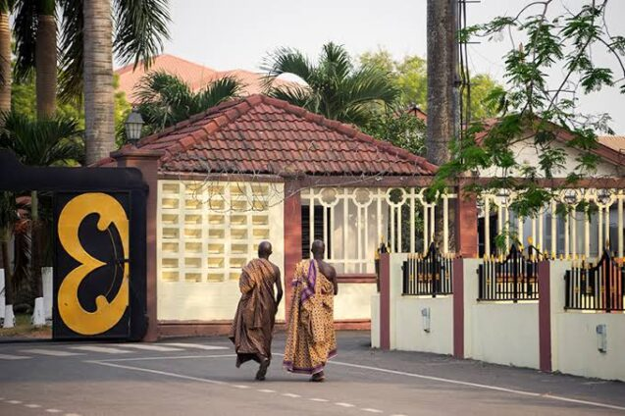

Technology-Page 8

Social media firms urge caution on early Australia under-16 ban data
Top social media platforms urged the Australian government not to place too much weight on early evidence showing that most children still use their products despite a landmark under-16 ban, as lawmakers consider tougher penalties and greater investigative powers for regulators.
Local heads of YouTube owner Google, Facebook and Instagram owner Meta,Snapchat and TikTok fronted a Senate inquiry ​as lawmakers pressed them on multiple studies, including from Australia's internet regulator, showing some 80% of minors were still ​on social media months after the ban took effect in December.
The hearing showed a persisting divide ⁠between lawmakers and big tech over whether the ban is working at a time when the eSafety Commissioner is considering ​legal action against some platforms, accusing them of deliberately slow-walking compliance to discourage other jurisdictions from copying it.
Commissioner Julie Inman Grant ​told the inquiry the March data suggested platforms were "failing to prevent the creation and recreation of accounts" but insisted the ban was showing early signs of working, citing a modest decline in numbers of underage accounts.
"We are seeing change but we need to give it time," Inman ​Grant said.
"Once that active enforcement starts, that's when the behaviour starts to change."
The inquiry is examining amendments that would double maximum ​penalties to A$99 million ($64 million) and expand the commissioner's powers to compel information and documents from platforms and their third-party age assurance providers ‌during investigations.
"It is a point in time, it's very early on, and we caution against over-reliance on that," YouTube's head of government relations Rachel Lord told the inquiry, noting the government's latest published compliance data was from March.
Age assurance technology had largely been built around a cut-off of 18, which many jurisdictions consider the transition from childhood to adulthood, and "the technologies that we are ​using to detect users at ​the 16 age boundary are ⁠evolving", Lord added.
Meta's Australia head of public policy Mia Garlick said the data on which the research was based may not reflect whether underage users had an account, even if they ​claimed to use a platform.
"There can be differences in terms of people accessing versus having ​an account," she ⁠told the inquiry.
"Sometimes survey data is challenging in terms of stated versus revealed."
Meta released figures a day earlier showing it had deactivated 756,000 Instagram and Facebook accounts suspected of belonging to underage users, up from about 500,000 in March. YouTube's Lord said Google has stopped about 740,000 holders of Google accounts from using their accounts on YouTube.
TikTok's Australian head of public policy, Jessica Loftstedt, said the company's compliance efforts were an "iterative process". The company had taken down 550,000 accounts when the law took effect ​and had since been removing about 24,000 a month.


France's top court blocks social media ban for under-15s
France's top court has struck down a ban on social media for under-15s, saying it infringed upon freedom of expression.
The legislation was backed by French lawmakers in July, making it the first European country to block young people from the platforms, after concerns over the harmful effects on children's mental health.
Friday's ruling by the Constitutional Council overrides the ban, which Emmanuel Macron had pledged would be introduced in stages from September.
Responding to the news, the French president immediately asked Prime Minister Sébastien Lecornu to prepare a new draft that would take into account all the council's points.
After lawmakers voted through the bill last month, Lecornu referred parts of the legislation to the council - a nine-member authority that checks whether a law complies with the constitution - for review.
The Constitutional Council said it had found that Article 1 of the legislation "constitutes an infringement that is neither appropriate, necessary, nor proportionate" to the freedom of expression and communication for under-15s.
The ruling also raised concerns over the law's requirement to provide proof of age to access online services and said it failed to establish "the legal safeguards necessary".
Macron's office said after the ruling that the French government would work "as quickly as possible" to propose a new draft and said the president was determined to see the reform implemented by early 2027.
The original legislation had envisaged that from September all those under-15 would not be able to open accounts, and verification would be required on all new accounts. And from January, this would have applied to all existing accounts.
Opponents have repeatedly questioned the law's viability and raised concerns over privacy, the efficacy of age-verification tools, the risks of young people bypassing them, and how quickly the ban has been designed and brought in.
Australia was the first country to introduce last December a social media ban for those under-16, although it is widely acknowledged that many in the country continue to use the platforms.
Legislation restricting young people's access to social media has been ramping up around Europe in the past few months.
In May, European Commission President Ursula von der Leyen proposed a "social media delay" for children in the EU, saying new legislation could be put forward in months.
In the UK, former British Prime Minister Sir Keir Starmer announced in June that under-16s in the UK will be banned from social media from January 2027. An optional midnight curfew for UK teens aged 16 and 17 was also announced.
AFP via Getty Images

Opinion -Page 9

The vulture of silence – Kurom Ayɛ Dinn

By: Kwesi Yankah

Is Ghana back to square one, still battling free speech?
Listen to the sad tale of women at the back of a recent street demo, 34 years into the 4th Republic.
‘I want to tell the President, and I beg to say, if I don’t speak well, please forgive me… (voice shaking). I want to ask the President: has he cancelled freedom of speech? If it’s been cancelled or withdrawn, he should let us know; he should tell us so we learn how to express ourselves… Life is tough in this country. That is the problem he should solve… Nobody is buying our wares… they are not buying…that is what he should solve. Not rampant arrests…(akyekyeakyekye) .. If freedom of speech has been withdrawn, he should tell us, so we know how to speak.’
Another woman, approximately 40: ‘Our eyes are red… we women… just check the colours we wear: black and red…We plead with the President… even if things did not go well with our speaking, we humbly plead; we are all his children, we are all one people… he should stop the rampant arrests… arresting our people… this is stressful.’
Another: ‘When we complain, they say we can’t talk…how do we express our opinion? Why allow this widespread stress in Ghana? (Afono yen), we are fed up…drive away the stress, let’s feel free.’
Finally, this old man: ‘These days they say you will be arrested if you speak about Mahama… I won’t speak, but I have only one request… JDM, please buy me a car,’ said a 60-year-old man, declaring his priorities.
Why are women’s voices particularly important to the nation of Ghana? Numerical majority. Overwhelming illiteracy. Censored by unfriendly language at formal forums: often ‘borɔfo nkoaa’; only 15% representation in parliament. When free speech was offered by the Constitution as a Gift, emphasis was on ‘Freedom and Independence of the Media’(Article 162). No direct reference to free speech (except within parliament). We simply have an arrogant constitution, written with an elite mindset.
Ghana’s Constitution has simply failed the ordinary man. Social media, with all its excesses, at least gives voice to the ordinary man: it says ‘express your raw wishes in any language.’
But listen again to the voices above: the unusual plea to the President: ‘even if our speech did not go well, please forgive.’ Women are aware they may have erred and not shown the normal cultural courtesies in speaking about elders.
Even so, Ghana, have we disappointed the silent downtrodden? Freedom fighters have recoiled into their shells after wiping their mouths. Is anybody home? ‘Kurom aye dinn’. Where is civil society: NGOs, the clergy, the Catholic Church, ‘the Fix Ghana’ forces, and their empty stomachs? ‘Kurom aye dinn. Yafunu no ayɛ ma.’
Where are the disciples of Ghana’s Free Press: Kweku Baako, Kofi Coomson, Kwesi Pratt? We miss you. Many are retired, but where is the new generation? 1994, I visited some of them at James Fort Prison while they were remanded and awaiting trial for a 2nd-degree felony!
‘Free Press’ and ‘Ghanaian Chronicle,’ did you fight in vain? Their offices were shit-bombed in 1994 to silence them.
They returned to fight on. Where are the likes of Kweku Sakyi Addo? 1997, his classic GTV Program ‘Kwaku One on One’ was taken off the screens. Prof PAV Ansah, the late ‘Saltpond Boy.’ It is not yet Uhuru. We miss his new generation. Ansah was the chief gladiator of Free speech. Even while he was battling stroke on his deathbed, PAVA was also battling press tyranny.
Has criminal libel law not been repealed? It has, but still, Kuromaye dinn.
What of the Mirror, the state-owned weekly that boldly hosted the Kwesi Yankah column for 10 years (1986-96)!
Kurom aye dinn.
It is understandable. New generations of champions may be too busy fulfilling a cultural imperative: ‘the good child does not talk while eating.’
Or this religious etiquette: ‘Ghanaian Media is in its Holy Temple: Let all the world be silent before Him.’
Media insults do not necessarily offend the law, but are simply unacceptable in civilized society. Smart politicians only wear thick skins, pretending they are deaf to insults. In crowd behaviour and processions, abuse and even obscenities are sometimes a breath of fresh air to society.
Busia regime 1969-72. He drove past the Kaneshie market every morning coming from his Odorkor home. Avoiding the use of convoys, Dr Busia joined slow traffic, and every day endured poetic abuse of ‘Busia Naabu’ merrily chanted by market women with reference to the Prime Minister’s puffy lips. Never did we hear a ‘Go for them’ order. No complaint, no arrests.
Also, Nana Addo’s father, Edward Akufo Addo Ghana’s ceremonial president. His modest neck profile in popular culture became the new name for Ghana’s mini club beer. ‘Give me one Akuuf’ was the routine order at the Legon cafeteria. No censorship, caution, nor warning given: ‘the wise elder pretends he has lost his hearing.’
Towards various elections since 1992, songs of abuse and death wishes abound: ‘Kill JJ for us’! At the historic Kumi Preko demo in 1996. ‘O Lord, kill Nana Addo for us; he is destroying the nation.’
Then a scandalous death wish directed at Bawumia, in addition to several spouse-centred abuses. Poor Samira. And when the police arrested one blogger, DMB intervened, pleading for his release. January 2023.
The famous eight Chiana girls, who took turns on social media to hurl abuse at Ghana’s foremost Gentleman, President NADAA, including ugly references to nether parts of the human anatomy. Public outrage followed, weeks of consultation, then dismissal letters from authorities.
Thick-skinned President Akufo-Addo feigned deafness; he abandoned meetings with the IMF and came calling for clemency: a mature democrat aware of risks in the game of politics.
Now this one in 2026. A heavy downpour of vulgar insults on President JDM by women bloggers. Clearly crude and unacceptable. But it is widely known: social media is not a textbook for exams, meant to be swallowed hook, line and sinker.’
It has its own world of make-believe and constraints. A rude gentleman squatting on his WC in Atlanta may, in full view of global cameras, choose to defecate on any revered King or chief; or even spit on a paralyzed president in a wheelchair, or even defile a global religion from a safe distance.
That’s social media at work. Rampant arrests in these hard times sound like beating a hungry boy and suppressing his tears. The vulture of silence has no place in today’s Ghana. As to where the vulture truly belongs, I leave that to Bukom Banku, who would point to the Vulture’s true home: Dansoman Borla, Brodo sɔɔnnn.



Entertainment-Page10

A Plus dismisses language barrier rumours in Parliament
Story: Entertainment Desk
Gomoa Central Member of Parliament (MP) Kwame Asare Obeng, popularly known as A Plus, has dismissed claims that his limited contribution on the floor of Parliament is due to an inability to speak English.
According to the musician-turned-politician, his focus is on delivering tangible results for his constituents rather than speaking frequently in Parliament simply to attract public attention.
A Plus described the claims as irritating, saying “they reflect a misunderstanding of what effective parliamentary representation entails”.
“Sometimes what makes me angry is when people say, ‘he doesn’t speak in Parliament because he can’t speak English’. They are misinformed people, and I don’t blame them. I feel sad for them,” he said.
He argued that frequent interventions on the floor should not automatically be equated with effective representation, noting that some MPs may speak often in Parliament without necessarily delivering meaningful results for their constituents.
A Plus cited his children, who live and were raised in London, as an example of how difficult some parliamentary debates can be to follow.
“The English that they speak in Parliament, when I show it to my kids, they say, ‘What are they saying?’ We have made it look like just going to the floor of Parliament and screaming makes you the best MP,” he said.
A Plus said he entered Parliament with a clear plan to use his position to bring meaningful change to Gomoa Central, rather than seeking recognition for his command of English.
He maintained that he would prefer to be remembered for the difference he makes in the lives of his constituents than for the number of times he speaks during parliamentary proceedings.

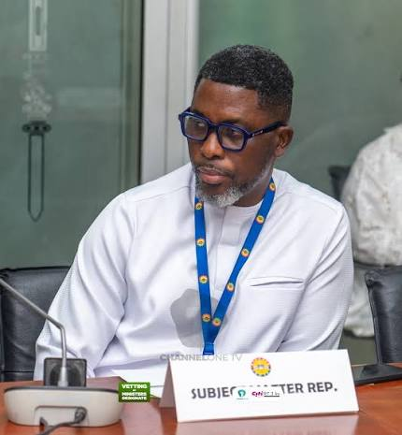

Davido crowns himself Nigeria’s top hitmaker
Afrobeats singer, David Adeleke, popularly known as Davido, has claimed that no Nigerian artiste has more hit songs than him.
He boasted that he was ready to bet $1 million on a hit battle with any Nigerian artiste who can challenge him.
The Omo Baba Olowo crooner challenged his colleagues to a hit contest during a recent livestream with streamer Davrel.
“I will put $1 million cash on the table. Nobody has more hits than me,” he said.
Davido is one of the most prolific hitmakers in the Nigerian music industry, alongside contemporaries such as Wizkid, Olamide, Burna Boy, Tekno and Runtown.
No artiste has publicly accepted his challenge.
It would be recalled Burna Boy made a similar challenge during the COVID-19 lockdown in 2020.
Former Mavin star, Reekado Banks, was the only artiste who accepted the challenge, but he was turned down by Burna Boy, who said he wasn’t “a worthy challenger.”


Tinubu not Nigeria’s real problem – Femi Kuti
Afrobeat legend Femi Kuti has claimed that President Bola Tinubu is not the major problem facing Nigeria.
He argued that the main problem in Nigeria was institutional corruption, stressing that if Nigeria had a good judicial system, Tinubu wouldn’t have been able to contest the presidency in the first place, given the multiple allegations against him.
Speaking in a recent episode of the Good News Naija podcast, Kuti said corruption in Nigeria was deeply rooted, emphasising that all the people entrusted with leadership across every sector belonged to the same class of corrupt elite.
“Do you think Tinubu is the problem? The judiciary that didn’t stop him from getting there in the first place is a problem. If all the allegations against him are true, how did he contest?
“If we had men and women of calibre and integrity, he wouldn’t have been able to contest in the first place,” he said.
Kuti added that systemic corruption in Nigeria was enough to dash the hopes of young Nigerians.
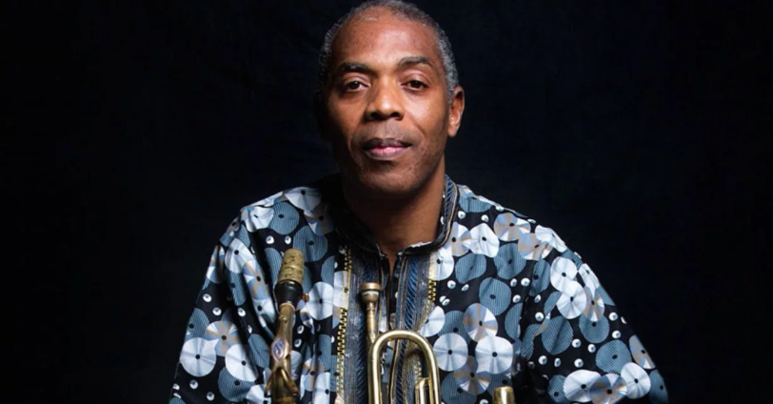

Sports-Page 11

New Zealand break with OFC to withdraw Infantino support

New Zealand have broken rank with Oceania's football governing body to become the latest nation to withdraw support for FIFA president Gianni Infantino.
Infantino has lost support from three regional confederations - Europe's UEFA, the Asian Football Confederation (AFC) and CONCACAF (North and Central America and the Caribbean) - over his aborted plans to sell 20% of the World Cup's commercial rights to private investors.
The Confederation of African Football (CAF) and South American governing body CONMEBOL have backed the 56-year-old to win a fourth presidential term at the FIFA Congress in March.
New Zealand have followed several individual member nations, including England, Wales, Norway, the Republic of Ireland and Northern Ireland, in confirming they will not support Infantino's re-election bid.
"New Zealand Football is also seeking an independent review of the steps undertaken to develop the FIFA Forward Enterprise Scheme (FFE)," a statement read.
"After careful consideration, NZF has formed the view that decisions and actions within FIFA have contributed to a breakdown in trust and increased division within international football, and that an independent review is required to restore confidence and trust.
"NZF believes this point in time represents an opportunity for all FIFA member associations to advocate for stronger governance, accountability and transparency, which are fundamental in maintaining confidence in the administration of the global game."
New Zealand was the only one of the OFC's 11 members to qualify for the 2026 FIFA World Cup, while fellow member New Caledonia have reaffirmed its support for Infantino.
CONCACAF members Mexico, Grenada and St Kitts and Nevis have gone against their federation and backed Infantino, while Argentina are aligned with CONMEBOL in their support.
NZF chief executive Andrew Pragnell said: "We've called for an independent review specifically because what we don't want to see is a sort of in-house quick wash-over of this.
"An independent review is something else that has been called for by other confederations that will help restore some of the trust."
The Oceania Football Confederation said it welcomed FIFA's decision to withdraw the proposal, but stopped short of declaring or withdrawing support for Infantino.
"The OFC Executive Committee welcomes FIFA's decision to withdraw the FFE proposal and its commitment to review the issues surrounding the project," the statement said.
"The OFC recognises the progress achieved over the last decade in advancing football development in Oceania under FIFA's leadership and encourages FIFA to use the review as an opportunity to identify and implement any changes that may be necessary."
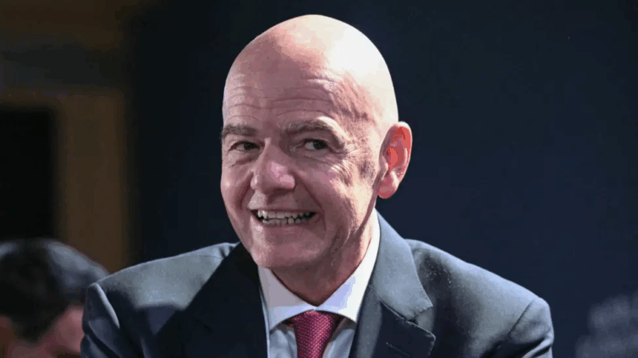

Bezos-backed consortium buys a third of Liverpool

Liverpool's owners have agreed to sell about a third of the club to a consortium including billionaire Amazon founder Jeff Bezos.
In a statement, Fenway Sports Group (FSG) confirmed it had entered into a "definitive agreement" for the sale of a "strategic minority investment" to 1892 Holdings.
The group is led by British-Indian millionaire businessman Amit Bhatia and also includes billionaire Facebook co-founder Eduardo Saverin.
Bhatia is set to become Liverpool's vice-chairman, and will join an expanded board pending regulatory approval.
The son-in-law of Indian billionaire businessman Lakshmi Mittal, he had been a director and co-owner of Queens Park Rangers for 18 years before relinquishing his stake in the club last month.
American businessman Bezos, founder of e-commerce giant Amazon, is the fourth-richest person in the world, with an estimated net worth of $256bn (£192bn). This marks his first foray into sports ownership, although he will not join Liverpool's board.
However, Bryan Baum, founder of venture capital firm K5 Sports - through which Bezos is investing - will join the Anfield board, alongside Saverin's wife Elaine. Bezos is the biggest investor in K5 Sports.
BBC Sport has been told that the transaction will have no impact on the club's approach to the transfer window, and that there is no new or separate transfer budget associated with the investment.
The agreement includes an option for the consortium to increase its investment in the future. That suggests the group will be in pole position to become majority shareholders if Fenway wants to sell up, but according to one source, no commitments have been made to do so.
The deal is said to value the club between £5bn and £6bn.
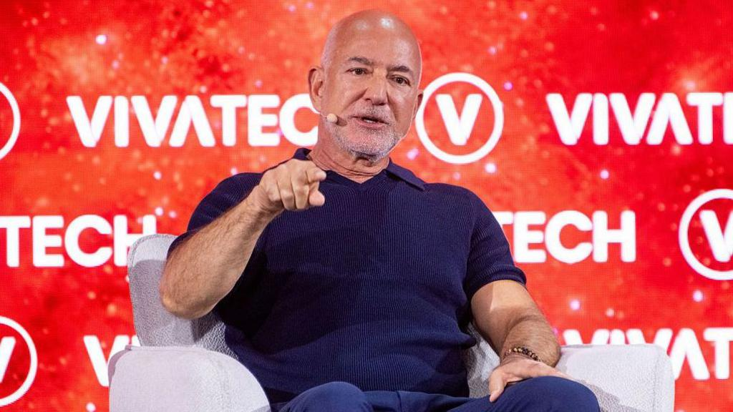

Algeria claim first-ever podium finish

*After penalty shootout win over hosts Morocco
Algeria secured a podium finish for the first time in their history at the TotalEnergies CAF Women’s Africa Cup of Nations Morocco 2026 after overcoming hosts Morocco 3-1 on penalties following a 1-1 draw in regulation time in Rabat.
After a disappointing loss to Malawi in the semi-finals, Algeria bowed out of the competition with their heads held high and a bronze medal to their name.
The hosts started brightly and came close to opening the scoring in the 17th minute when Ibtissam Jraidi’s first-time effort struck the crossbar.
Morocco eventually found the breakthrough nine minutes later. Kautar Azraf showed impressive technique to eliminate her marker before using her left foot to find the far corner and put the hosts ahead.
Azraf almost doubled Morocco’s advantage soon afterwards with a volley, but the effort bounced awkwardly and lost direction before being cleared to safety.
In the 77th minute, a perfectly weighted ball found captain Marine Dafeur in a promising position, but she was unable to direct her effort towards goal.
Three minutes later, Lina Boussaha came close with a well-struck volley that sailed narrowly over the crossbar.
The pressure finally paid off in the 83rd minute after Melissa Bethi produced a brilliant through ball for Boussaha, who showed composure to tuck the ball past the goalkeeper and level the contest at 1-1.
Neither side could find a winner before the final whistle, sending the match to a penalty shootout.
After an intense exchange from the spot, Algeria held their nerve to prevail 3-2, with Ines Belloumou converting the decisive penalty to seal a memorable victory.
The result earned Algeria a bronze medal and a podium finish at the TotalEnergies CAF Women’s Africa Cup of Nations Morocco 2026, while hosts Morocco finished fourth after an impressive run on home soil.


Backpage-Advert

